**Experiment 2 : Web Analytics**

|  |  |
| --- | --- |
| **Name of Student** | **AKRUTI DABAS** |
| **Class Roll No** | **D15A/11** |
| **D.O.P.** |  |
| **D.O.S.** |  |
| **Sign and Grade** |  |

**AIM : To study a Web Analytics Tool Theory:**

1. **What is Web Analytics?**

Web Analytics is the process of collecting, analyzing, and reporting website data to understand user behavior, measure performance, and optimize digital strategies. It helps businesses track metrics like visitor traffic, engagement, conversions, and retention to improve website efficiency and user experience.

1. **Web Analytics Tools and Their Features**

There are several web analytics tools, each offering unique features to help businesses and individuals analyze and improve their web presence.

1. Google

Analytics Features:

* + Tracks website traffic and user behavior.
  + Provides real-time data insights.
  + Offers audience segmentation and demographic reports.
  + Tracks conversion rates and goal completions.
  + Integrates with Google Ads for ad performance analysis.
  + Provides event tracking to monitor user interactions.

1. Adobe

Analytics

Features:

* + Advanced customer segmentation and predictive analytics. ● AI-powered insights with Adobe Sensei.
  + Integration with Adobe Marketing Cloud.
  + Path analysis for understanding user journeys. ● Custom reporting and data visualization.

1. H

otjar

Features:

* + Heatmaps to visualize user clicks, scrolls, and movement.
  + Session recordings to analyze user behavior.
  + Survey and feedback tools to collect user opinions.
  + Funnel analysis to identify drop-off points in conversion.
  + Form analytics to optimize web forms.

1. Matomo (formerly

Piwik) Features:

* + Open-source web analytics platform with full data ownership.
  + GDPR and privacy-complaint tracking.
  + Provides heatmaps, session recordings, and A/B testing.
  + Customizable dashboards and reports.
  + Supports goal tracking and e-commerce analytics.

1. Craz

y Egg

Features:

* Heatmaps to visualize user interaction.
* Scroll maps to understand how far users scroll.
* A/B testing to compare different web page versions.
* User session recordings for behavioral insights.
* Confetti tool to segment clicks by referral source, device, and other parameters.

**3. Why is it Important to Learn Web Analytics?**

Learning web analytics is essential for anyone involved in digital marketing, website development, or online business growth. Some key reasons include:

1. Data-Driven Decision Making – Helps businesses make informed decisions based on user behavior and trends.

1. Optimizing User Experience – Identifies pain points and areas for improvement on websites. Improving Conversion Rates – Tracks user journeys to optimize marketing strategies and increase sales.
2. SEO and Performance Enhancement – Provides insights into traffic sources and search engine performance.

1. Understanding Audience Behavior – Segments users based on demographics, interests, and interactions.

1. Cost Efficiency in Marketing – Helps allocate budgets effectively by analyzing ROI on marketing campaigns.

**4. Key Performance Indicators (KPIs) for Your Website:**

Link to website: [Link](https://moresanket4003.github.io/ip_assign_bootstrap/)

1. Here we can see that the number of active users is 44 and the event count is 227 and in the picture below this the page view is 12 but the scroll is 4 so many visitors to the website do not scroll down in the website

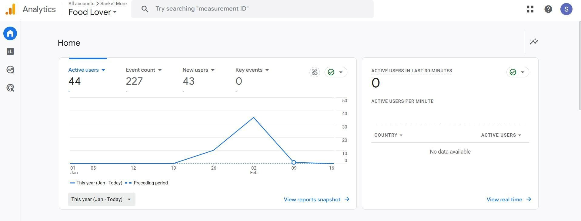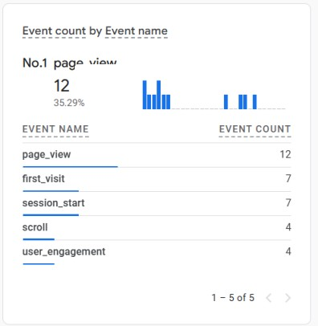

This gives the analysis of traffic on each page of the website.

1. Here we can see the the demographic visitors of our website where majority of the visitors are from Mumbai,India

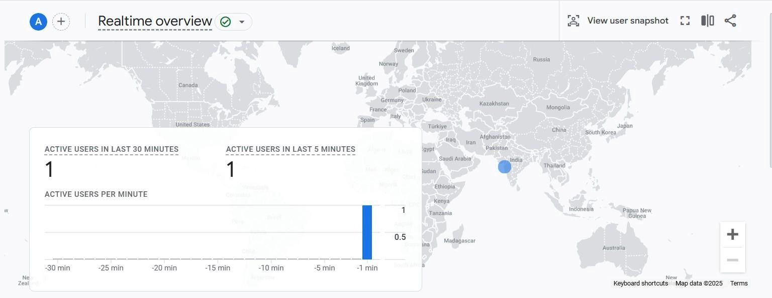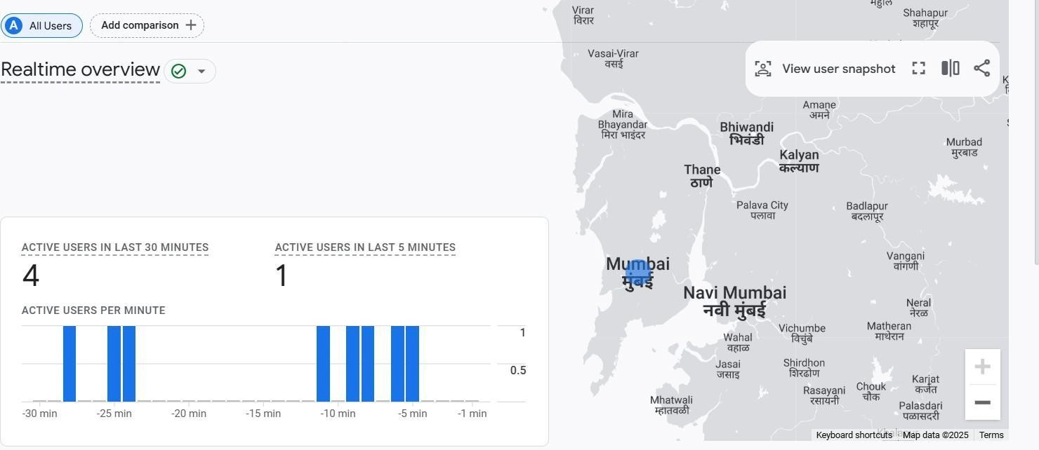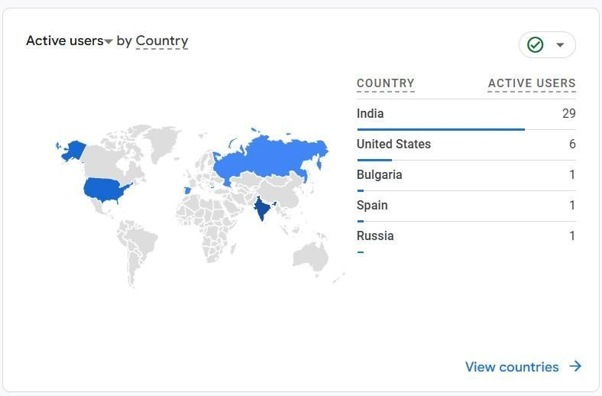

The above picture gives us demographic information from where our user base is.

1. This image shows how people reach our website by using the URL . Many are reaching directly and only a few are reaching via referrals so we have to improve the referral rate of our website.

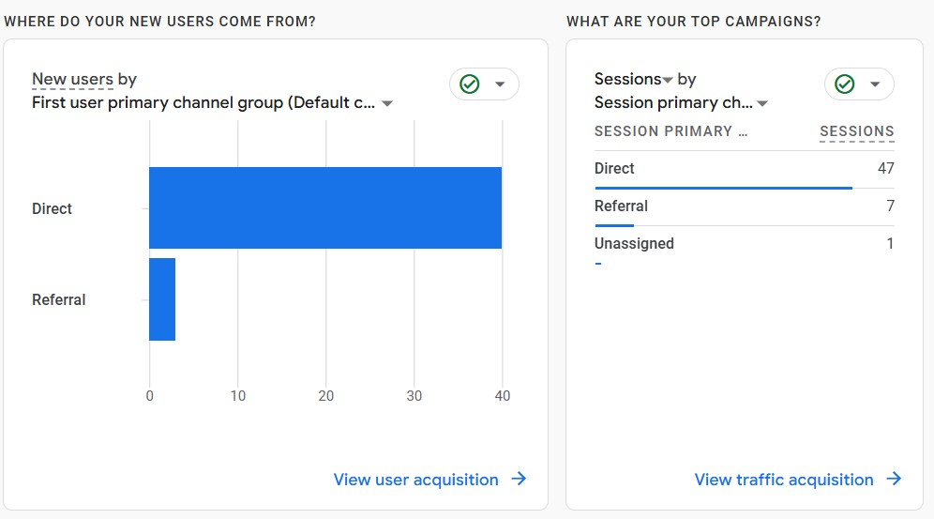

1. shows what all events have been done by users on the website for example:53 people viewed the page.

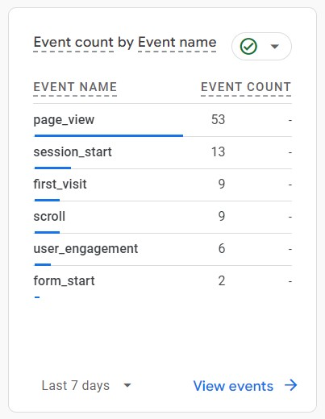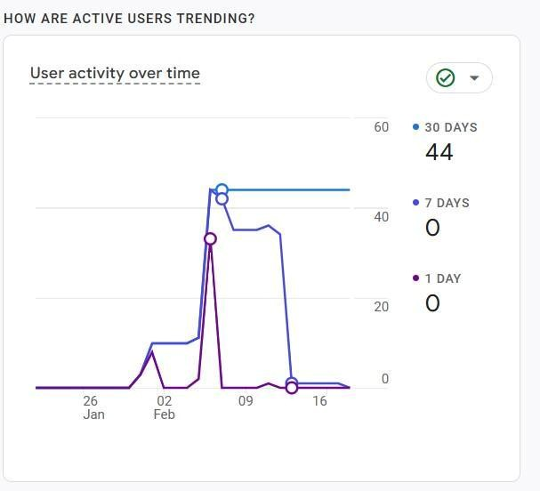

1. Show the user activity over the past 7 days, after adding Google Analytics script to website.

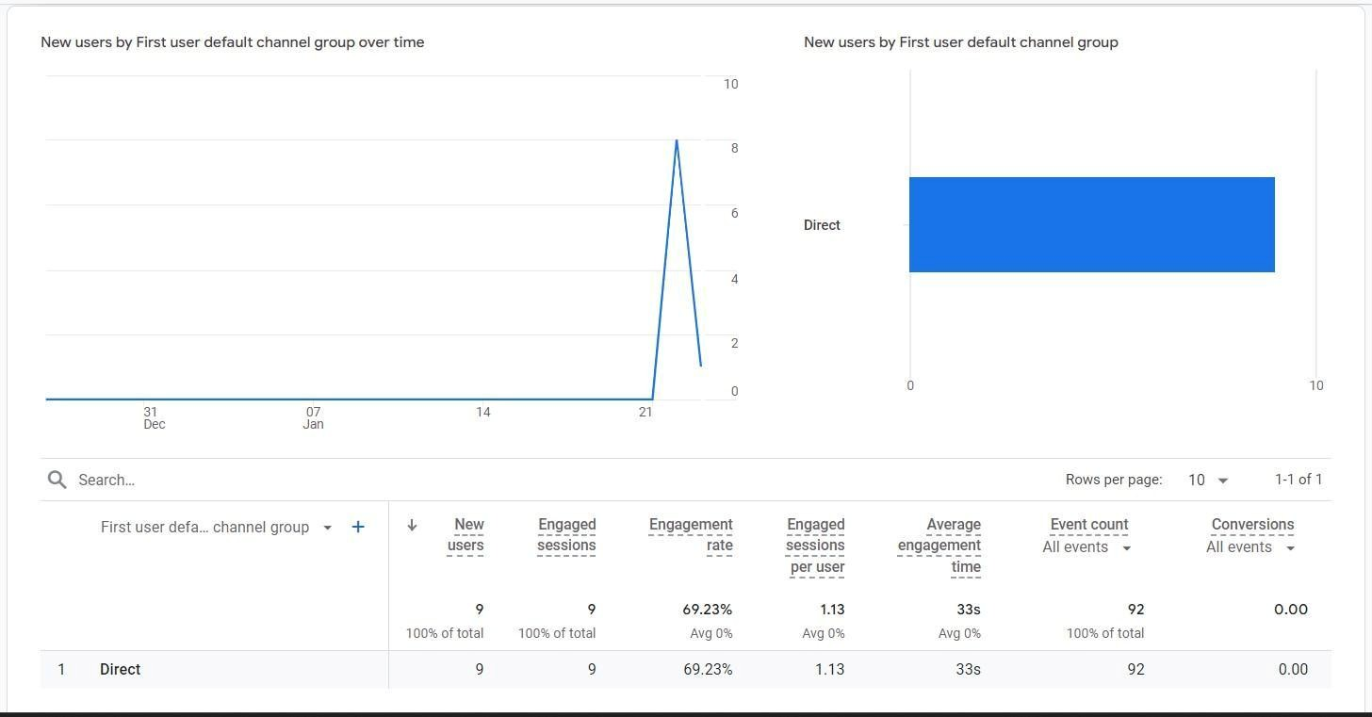

This shows the complete details about the engagement session, avg engagement time, event counts, etc.

**CONCLUSION :**

In conclusion, our web analytics experiment highlights the need to enhance user engagement by increasing the scroll rate and ensuring visitors interact more with our content. To achieve this, we can focus on improving page design, adding interactive elements, and optimizing content placement to encourage deeper exploration. Additionally, expanding our international user base requires implementing multilingual support, localized content, and targeted marketing strategies to attract a diverse audience. By continuously analyzing user behavior and refining our approach, we can create a more engaging experience and drive higher conversions.